**Ivan Edward Sutherland**

***The father of computer graphics***

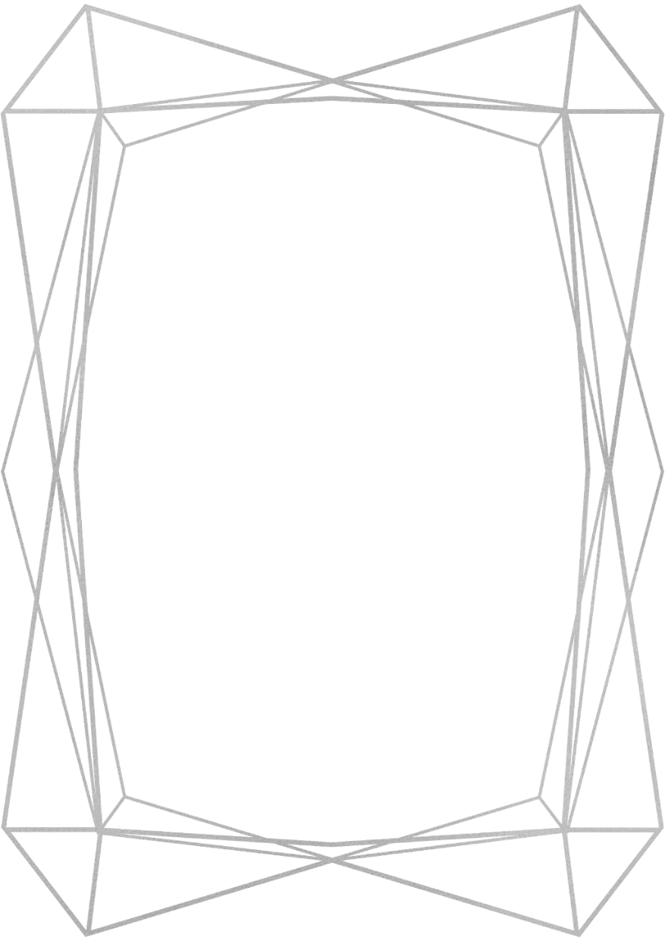

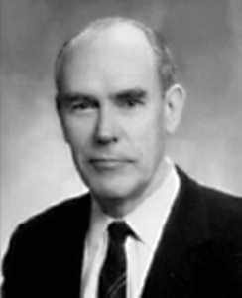

**"A display connected to a digital computer gives us a chance to gain familiarity with concepts not realizable in the physical world. It is a looking glass into a mathematical wonderland." – Ivan Sutherland**

**Liam Egan 17340992**

Introduction:

Ivan Edward Sutherland (81) was born in Hastings, Nebraska on May 16, 1938. He is an American computer scientist and Internet pioneer, regarded by many to be the "father of computer graphics". Through his early work in computer graphics as well as his collaborative and pioneering teaching with David C. Evans in computer graphics at the University of Utah in the 1970s - Sutherland, Evans, and their students from that era invented several foundations of modern computer graphics.

Awards and Recognition:

He received the Turing Award from the Association for Computing Machinery in 1988 for the invention of Sketchpad, an early predecessor to the sort of graphical user interface that has become ubiquitous in personal computers. He is a member of the National Academy of Engineering, as well as the National Academy of Sciences. In 2012 he was awarded the Kyoto Prize in Advanced Technology for "pioneering achievements in the development of computer graphics and interactive interfaces". Sutherland also received an Honorary Master of Arts Degree from Harvard University in 1966. Sutherland earned his Bachelor's degree in electrical engineering from the Carnegie Institute of Technology, his master's degree from Caltech, and his Ph.D. from MIT in EECS in 1963.

Biography:

Early Life:

His father was a practicing engineer with a Ph.D. in civil engineering. His mother was a teacher who instilled in him and his brother Bert a love of learning.

In 8th grade of school he built a gantry crane with motors his father brought home with him from his workplace. His favorite subject in high school was geometry. A self-described visual-thinker, Sutherland once said (“If I can picture possible solutions, I have a much better chance of finding the right one”), which led to his interest in computer graphics.

His first computer processing experience was with a computer called SIMON, a relay-based computer with six words of two-bit memory, which was lent to the Sutherland household in 1950 by its designer, Edmund Berkeley. Its 12 bits of memory permitted SIMON to add up to 15. Sutherland's first significant program allowed SIMON to divide. In order to perform division, he was required to use a table look-up and added a conditional stop to SIMON's instruction set. This program was a great accomplishment, it was the longest program ever written for SIMON, requiring eight feet of paper tape to run.

Education:

Sutherland was one of only a few young students writing computer programs at the time. For a 12th grade science fair project, he made a magnetic drum memory with 128 2-bit words. Sutherland published “An Electro-Mechanical Model of Simple Animals” in Computers and Automation at the young age of 19. At age 21 he published “Stability in Steering Control” in Electrical Engineering.

After graduating from Scarsdale High School in 1955, Sutherland attended Carnegie Mellon University on a full scholarship. He received a Bachelor of Science Degree from Carnegie in 1959, a Master of Science Degree from the California Institute of Technology in 1960 (which he selected to get as far as possible from his new mother-in-law, or so he claims), and a Doctor of Philosophy Degree in Electrical Engineering from the well-known Massachusetts Institute of Technology (MIT) in 1963.

Later Life:

Sutherland replaced J. C. R. Licklider as the head of the US Defense Department Advanced Research Project Agency's Information Processing Techniques Office (IPTO), when Licklider returned to MIT in 1964.

Sutherland was a Fellow and Vice President at Sun Microsystems – the company that created the programming language Java. Sutherland was a visiting scholar in the Computer Science Division at University of California, Berkeley (Autumn 2005–Spring 2008). On May 28, 2006, Ivan Sutherland married Marly Roncken. Sutherland and Marly Roncken are currently leading the research in Asynchronous Systems at Portland State University.

Sutherland has two children with Marly Roncken. He also has a brother, Bert Sutherland, who is also a computer science researcher.

Projects and Contribution to Computer Science:

While at MIT in 1962, Sutherland invented Sketchpad. Professor Claude Shannon signed on to supervise Sutherland’s computer drawing thesis. Sketchpad was an innovative program that influenced forms of interaction with computers that differ from the standard keyboard and mouse input. Sketchpad could accept constraints and specified relationships among segments and arcs, including the diameter of arcs. It could draw both horizontal and vertical lines and combine them into figures and shapes. Figures could be copied, moved, rotated, or resized, retaining their basic properties. Sketchpad also had the first window-drawing program and clipping algorithm, which allowed users to zoom in and out of their drawings. Sketchpad ran on the Lincoln TX-2 computer and influenced Douglas Engelbart's oN-Line System. Sketchpad was influenced by the conceptual Memex envisioned by Vannevar Bush in his paper "As We May Think".

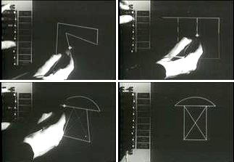

Sketchpad in use.

In 1968 he co-founded Evans and Sutherland with his friend and colleague David C. Evans. The company did pioneering work in the field of real-time hardware, accelerated 3D computer graphics, and languages for printers. Some notable former employees of Evans and Sutherland included the future founders of Adobe (John Warnock) and Silicon Graphics (Jim Clark).

From 1974 to 1978 he was the Fletcher Jones Professor of Computer Science at California Institute of Technology, where he was the founding head of that school's Computer Science department. The consulting firm founded by Sutherland - Sutherland, Sproull (a man with whom he would collaboratively write a book) and Associates, was purchased by Sun Microsystems to form the seed of its research division, Sun Labs – the company behind the most widely-used programming language, Java.

Bibliography:

Ivan Sutherland. (2019, September 22). Retrieved from <https://en.wikipedia.org/wiki/Ivan_Sutherland>.

Ivan Sutherland. (n.d.). Retrieved from <https://amturing.acm.org/award_winners/sutherland_3467412.cfm>.

Ivan E. Sutherland. (n.d.). Retrieved from <https://www.computerhistory.org/fellowawards/hall/ivan-e-sutherland/> Robert Burton.

Ivan Edward Sutherland. (n.d.). Retrieved from <https://history.computer.org/pioneers/sutherland.html>.

Editor. (n.d.). Ivan Sutherland - Father of Computer Graphics. Retrieved from <https://www.i-programmer.info/history/8-people/329-ivan-sutherland.html>.

# Sutherland, Ivan Edward (1963) Sketchpad: A man-machine graphical communication system (Technical report - Massachusetts Institute of Technology. Lincoln Laboratory) Nebraska, U.S: Unknown Binding